EXAMPLE-1: NAMES AND IMAGES AS TABLES

The format of docker ps can be formatted to only display the information relevant to you.

START EXAMPLE CONTAINER

Start by launching a example container - docker run -d redis

FORMAT

The standard docker ps command outputs the name, image used, command, uptime and port information.

To limit which columns are displayed, use the _--format__ parameter. The parameter allows pretty-printing containers using a Go template syntax.

docker ps --format '{{.Names}} container is using {{.Image}} image'

As it's using Go templates, it includes helper functions such as *table*.

docker ps --format 'table {{.Names}}\t{{.Image}}'

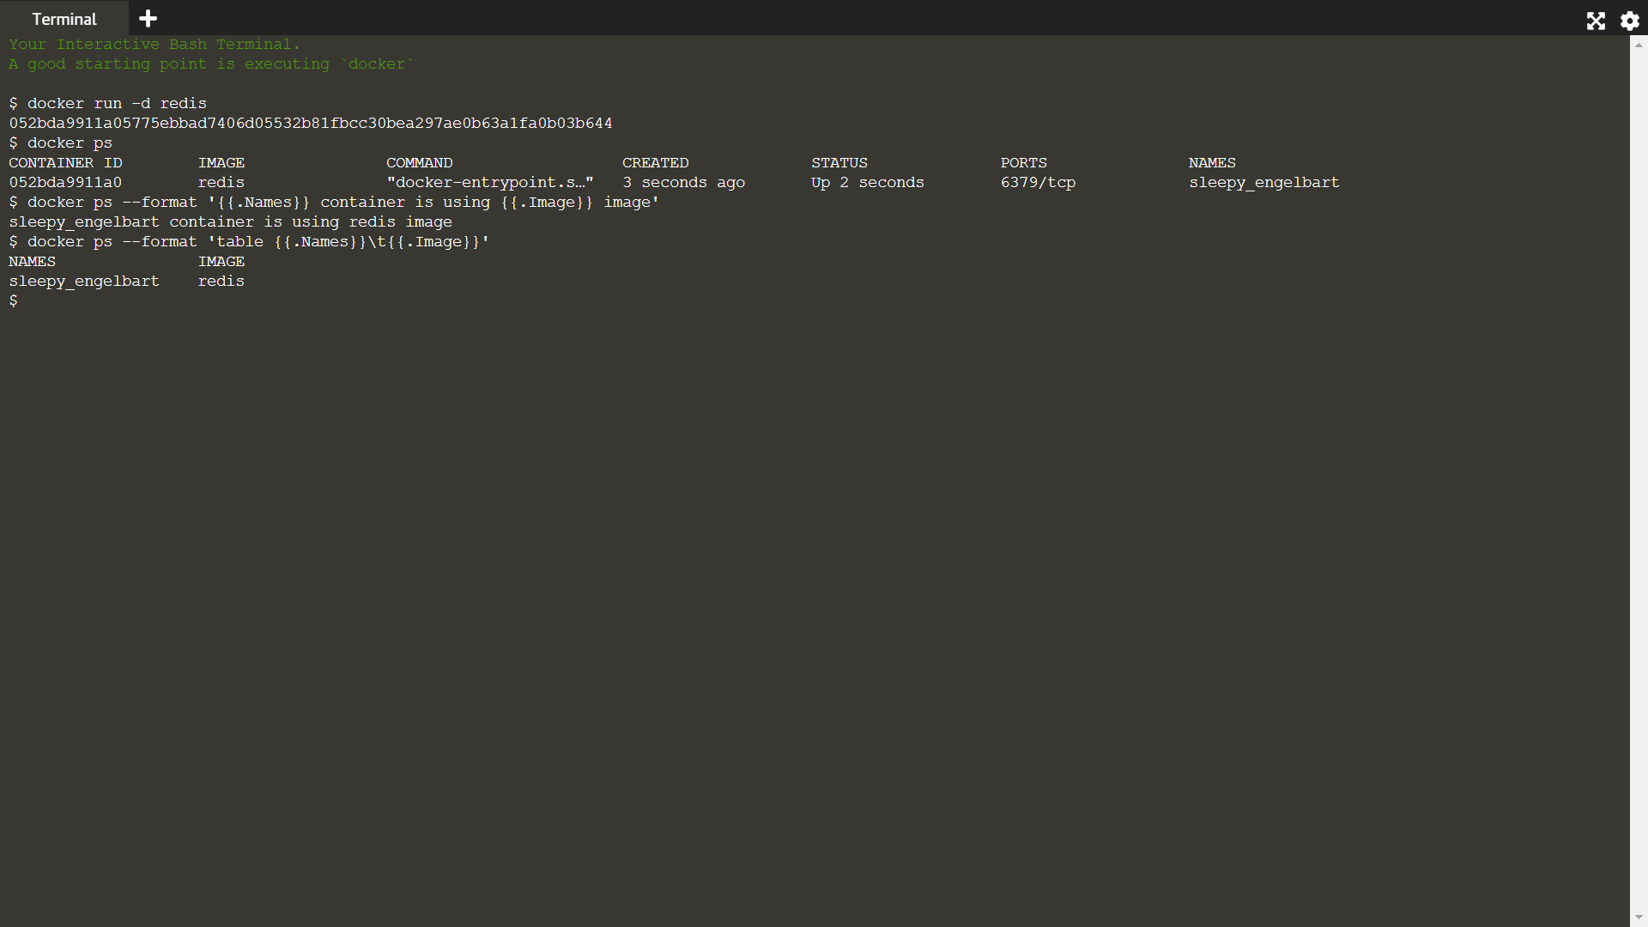

EXAMPLE-2

However, the format parameter allow supports displaying data that is already exposed via the docker ps command. If you wanted to include additional information, such as the IP Address of the container, then the data needs to come via docker inspect.

Thankfully, the docker inspect also supports pretty-printing the results via a Go Template. The container IDs from docker ps can be piped into docker inspect.

The format parameter can then access all of the container information. Below is an example of listing all the IP addresses for the running containers.

docker ps -q | xargs docker inspect --format '{{ .Id }} - {{ .Name }} - {{ .NetworkSettings.IPAddress }}'

S